**gs:** #[GPS](http://www.bandwidthblog.com/tag/gps/)#[live](http://www.bandwidthblog.com/tag/live/)#[South Africa](http://www.bandwidthblog.com/tag/south-africa/)#[tomtom](http://www.bandwidthblog.com/tag/tomtom/)#[traffic](http://www.bandwidthblog.com/tag/traffic/)

**Categories:** [Gadgets](http://www.bandwidthblog.com/category/gadgets/), [South Africa](http://www.bandwidthblog.com/category/south-africa/), [Web](http://www.bandwidthblog.com/category/web/)

[TomTom lets you see current South African traffic conditions, for free.](http://www.bandwidthblog.com/2011/03/17/tomtom-lets-you-see-current-south-african-traffic-conditions-for-free/)



Published by [Minnaar Pieters](http://www.bandwidthblog.com/author/minnaarpieters/) on Mar 17th, 2011, [8 Comments](http://www.bandwidthblog.com/2011/03/17/tomtom-lets-you-see-current-south-african-traffic-conditions-for-free/#comments)

How nice – up until now SA did not have proper online traffic reports as they happen, and only recently did these services become available on GPS navigation devices. However there are many people who rely on online services to quickly figure out a route to their destination. While other countries have had traffic conditions built into [Google Maps](http://www.bandwidthblog.com/2010/05/17/google-street-view-for-sa/), SA has not been so lucky so far. Luckily Tomtom has stepped up  - they are making their actual live HD Traffic service available to anyone with a browser. While the interface is nothing fancy, it works well enough.

[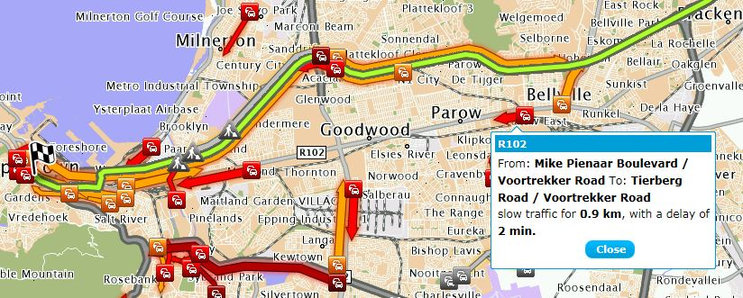](http://www.bandwidthblog.com/wp-content/uploads/2011/03/TomtomLiveCapeTown.jpg)

I tried it out this morning, and it seems spot on in its traffic reports. You can see what distance a traffic jam might be, or what kind of delay it puts on your trip. Things like accidents and roadworks are included as well. I did a quick route plan from Stellenbosch to Cape Town, and sure enough it made a diverted route for me, that minimizes delays.

I think a few people might be wondering why TomTom would make this data freely available – I think its a reminder to people what a great tool live traffic would be on a GPS device. While planning the route I keep thinking it would be a great feature to have on my GPS or phone… Smart move Tomtom. So does the Tomtom app for [iPhone](http://www.bandwidthblog.com/2010/09/21/iphone-4-pricing-south-africa/) have Traffic reports?

If you want to go try it out - [http://routes.tomtom.com](http://routes.tomtom.com/)

<http://www.seomoz.org/learn-seo/internal-link>

<a href="http://www.same-domain.com/" title="Keyword Text">Keyword Text</a>

http://whoisly.com/source/tomtom.com/livetraffic/